|  |  |
| --- | --- |
| ooxWord://word/media/image2.png | **Athlone Institute of Technology****Institiúid Teicneolaíochta Bhaile Átha Luain** **Department of Mechanical Engineering** |

Course: Bachelor of Engineering (Hons) in Mechanical Engineering

2020/2021

##### Manufacturing Automation 4

##### Continuous Assessment

**Student Name** Zien Zheng **Student No** A00268964

**Date** 6/12/2020 **Title** Robotic Assignment

Check List (You are required to tick all of the items on following list)

|  |  |
| --- | --- |
| I have read and understood all the requirements for submission of this report |  |
| I have included overleaf a fully completed and signed **STUDENT PLAGIARISM DISCLAIMER FORM A1** |  |

Contents

**Athlone Institute of Technology** 1

**Institiúid Teicneolaíochta Bhaile Átha Luain** 1

Introduction (87 words) 2

Objectives (493 words) 2

Methodology (300 words) 4

Solution (part a[147 words], part b[156 words]) 7

Discussion (Part a[196 words], Part b[600 words]) 14

Conclusion (49 words) 20

Figure 1: Interaction with slider via digital Input and Output 3

Figure 2: Fixed Point 4

Figure 3: PalletAssembly model for Part a 5

Figure 4: MPS-RobotStation for part b 6

Figure 5: Project Management Setting for part b 7

Figure 6: IO information used in part b 7

Figure 7: Part A(1) 8

Figure 8: Part A(2) 9

Figure 9: 2X3 test result 9

Figure 10: Part A(3) 10

Figure 11: Part B(1) 11

Figure 12: Part B(2) 11

Figure 13: Part B(3) 12

Figure 14: Part picked 12

Figure 15: Activation 13

Figure 16: Part B(4) 13

Figure 17: Use gripper2 14

Figure 18: Part B(5) 14

Figure 19: Store 14

Figure 20: Part B 15

Figure 21: PLT 15

Figure 22: Solution 16

Figure 23: 3X3 Test 16

Figure 24:Speed control 16

Figure 25: Speed setting 17

Figure 26: Dimension 17

Figure 27: Change gripper 17

Figure 28: Use gripper2 18

Figure 29: Definition 18

Figure 30: Interruption 18

Figure 31: Interruption monitoring period 19

Figure 32:Sensor 19

Figure 33: Definition of B1, CYLTYPE and store result 19

Figure 34:Rotation 20

Figure 35: Circle 20

Figure 36: Code for scribe circle 20

Figure 37: Z-correction variable 20

Introduction (87 words)

The use of industrial robotics has greatly freed the workers from heavy, dangerous, and repetitive tasks, as well as help the factory to improve productivity and quality. Besides, compared to man, robotics can work in a worse environment constantly but running stably. And due to the programable property, the robotics can achieve the expected function by writing code based on task requirements in different application scenarios.

In this lab, there are two types of robotics were used and by programming to achieve palletising and classification tasks, respectively.

Objectives (493 words)

Part a:

Palletising

The brief goal of this part is programming the robot to pick cubes from the slider and palletise them on the pallet with definable rows and columns settings.

More detailed steps are shown as follow:

* The robotics used in this part is based on the “PalletAssembly” Ciros Robotics simulator model
* Define the variables and pallet.
* The rows and columns are changeable integer variables, and the ranges are from 1 to 4, which means the total number of cubes palletised will be changeable as well.
* The program will interact with the slider in the model which by controlling the specific IO shown below for slide down the cubes.

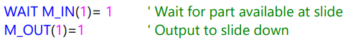

Figure 1: Interaction with slider via digital Input and Output

* Safety factors need to be considered, which including the speed control of robot and approach and away method.
* When the work is done, the robot should return to initial start position and program should end.

Part b:

Manufacturing Station

The goal for this part can be briefly stated as checking whether the part is on the pedestal, then pick it and place on test point and activate the colour sensor to recognize its colour and rotate an angle corresponding to its type of colour and put it on the assembly point and then drop it to the corresponding magazine based its colour as well, and finally draw a circle above the magazine. The detailed steps are shown as follow:

* The robotics used in this part is based on the “MPS-RobotStation” Ciros Robotics simulator model
* Use only the following fixed points, all rest movement of the robot should base on these points.

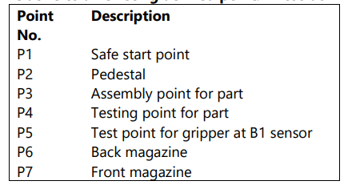

Figure : Fixed Point

* An input signal “STOP” is required, and once it is turned on, the robot should stop and wait for the signal to turn off, after that, the program should return to the beginning.
* Checking the input signal “PART_AV” to determine if the part is available on the pedestal.
* There should be an output signal “RUNNING” to show the status of the station when the robot is moving, the output signal should be ON.
* Picking the part from pedestal should use gripper 1.
* Put the part on the test point and use gripper test point to activate the sensor and obtain the testing result.
* Use gripper 2 to pick up the part and rotate +45 degrees if the part is black or rotate -45 degrees if the part is silver or red, rotation happens on the horizontal plane.
* Put the part on the assembly point.
* Use gripper 1 to pick up the part and drop to the magazine corresponding to the type of part colour.
* Use gripper test point to draw a circle around the top surface of the same magazine.

Both parts are achieved by using MelfaBasic IV language to program. And all parts needed to fully comment on the code.

Methodology (300 words)

CIROS Robotics is the simulation software being used in lab, and the models were opened at Help Index of Models option with opening the user model:

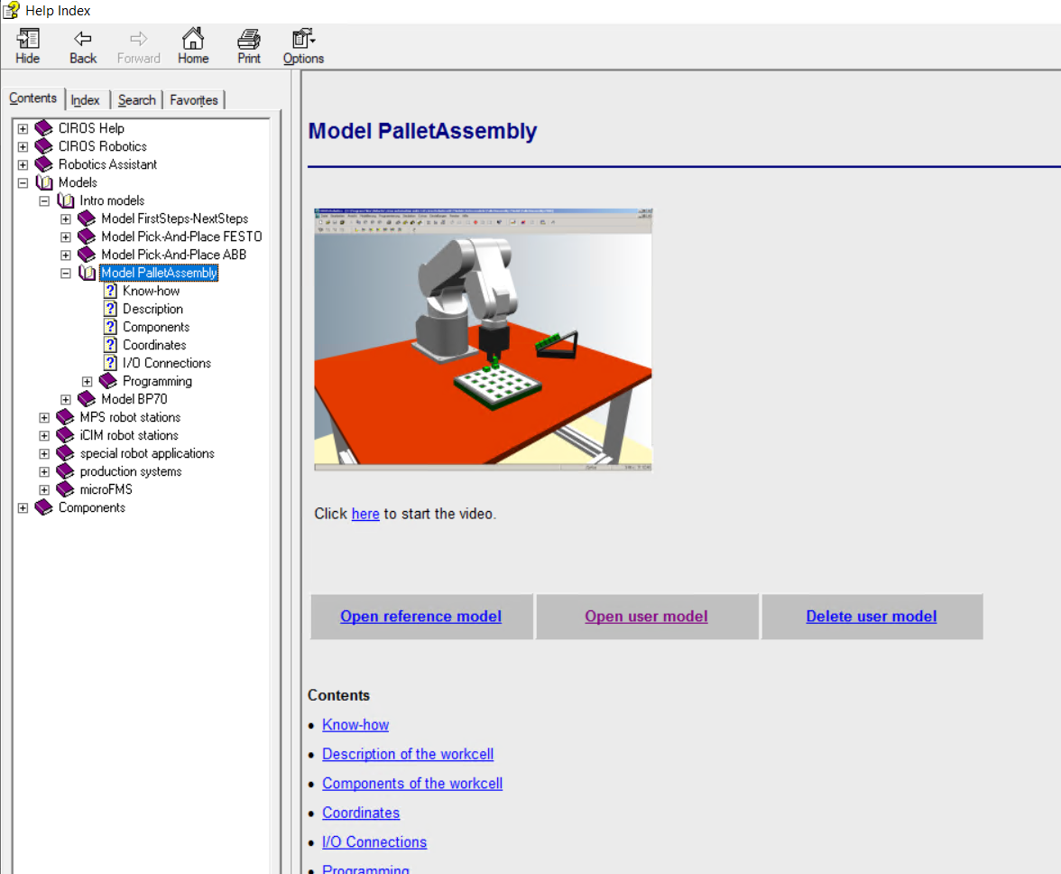

Figure 3: PalletAssembly model for Part a

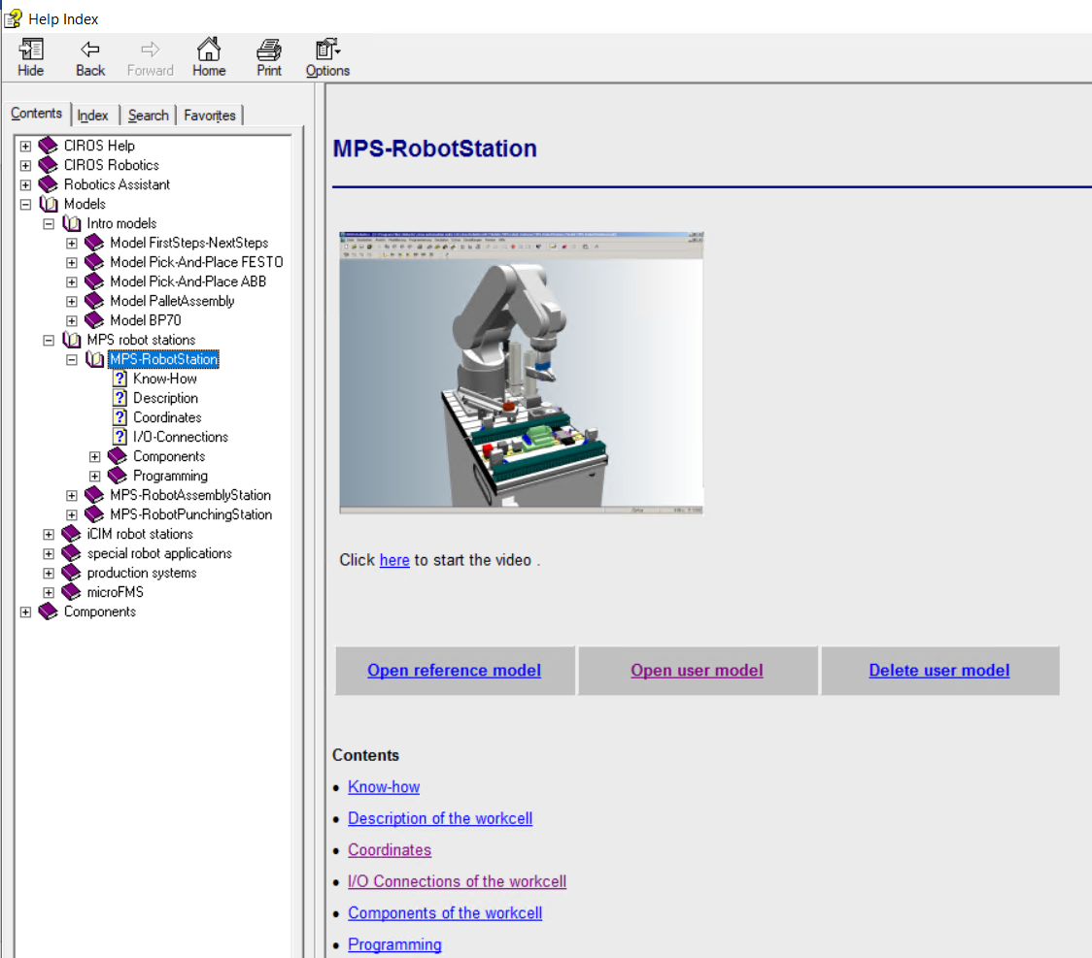

Figure 4: MPS-RobotStation for part b

Then, at Project Management on the toolbar, a new project file can be created and set as Active Project by default, then, a .mb4 file for code, a .pos file for store position points also can be created and insert into the project. Because for both parts in this lab, only one code file(.mb4) being used for each, so, the compile mode for new created .mb4 file should be set as Main Program.

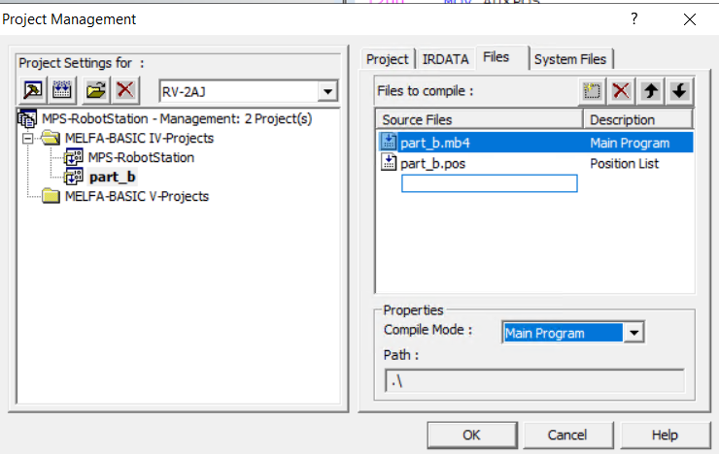

Figure 5: Project Management Setting for part b

When finding the position with teach-in tool or writing code, the sample file of position and code can be used as a reference which these files will be opened automatically when open the model. Besides, the model’s mechanical properties and IO information can be obtained from the help file corresponding to each model.

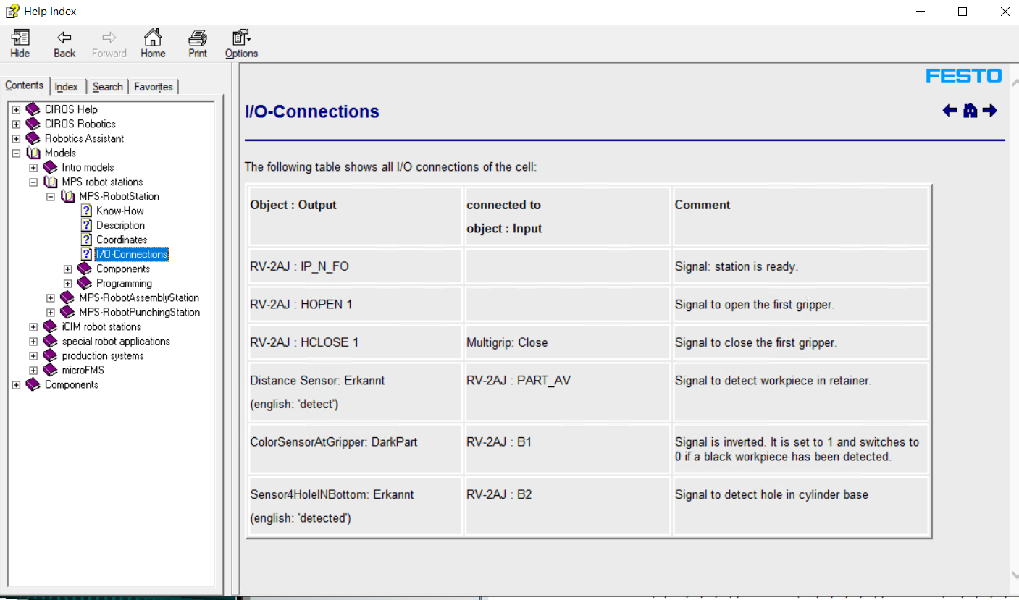

Figure 6: IO information used in part b

Once the positions are found, then, programming can start. The programming language being used is MelfaBasic IV language, the usage of command and parameters of command can be learned from the MELFA instruction manual. And there are also some very similar commands, for example, MOV and MVS, which they are both used to move the robot to another position, but their motion track is different, so, the next step is recognizing how to use these command properly. Meanwhile, the program can be tested by compile the code file and see whether error occurs or whether the robot running as expected.

Finally, check the code, and adjust the code structure to meet the standard and fully comment on the code.

Solution (part a[148 words], part b[156 words])

Part a:

4 functions will be executed in the main function.

*DefVars: Define the variables being used in this program of including the integer and position variables.

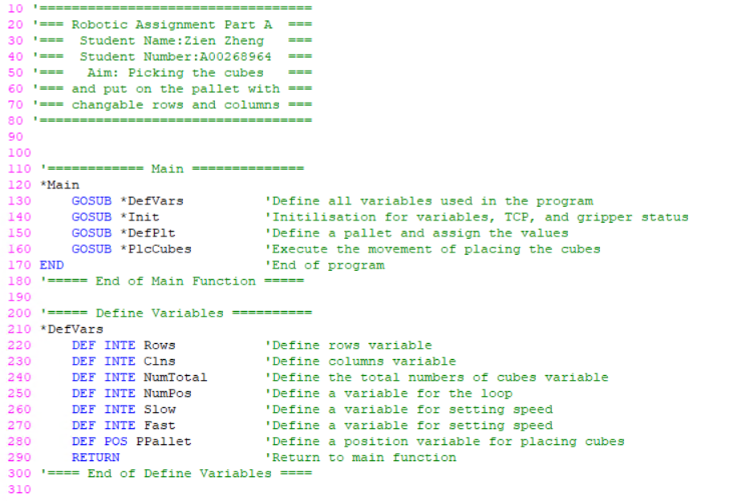

Figure 7: Part A(1)

*Init: Assign the values for the variables and initializing the speed, moving the TCP to the start position, and open the gripper.

*DefPlt: A pallet will be defined based on initialized variables, so, PLT function can be used to calculate the palletizing position for each cube.

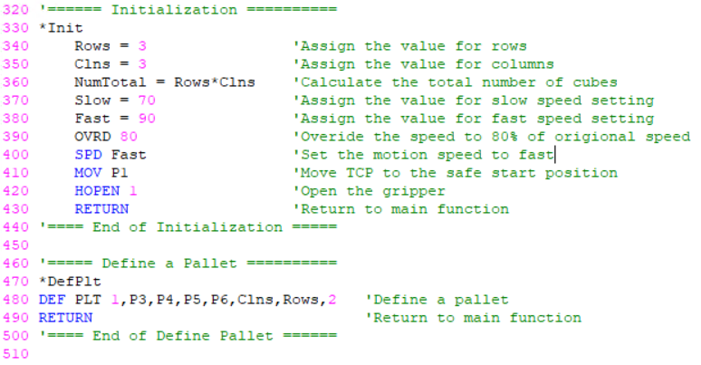

Figure 8: Part A(2)

*PlcCubes: The increment of 1 in the loop for NumPos is one of the parameters at PLT function to obtain each cube’s position as PLT will return the position of number [NumPos] part’s position corresponding on the pallet.

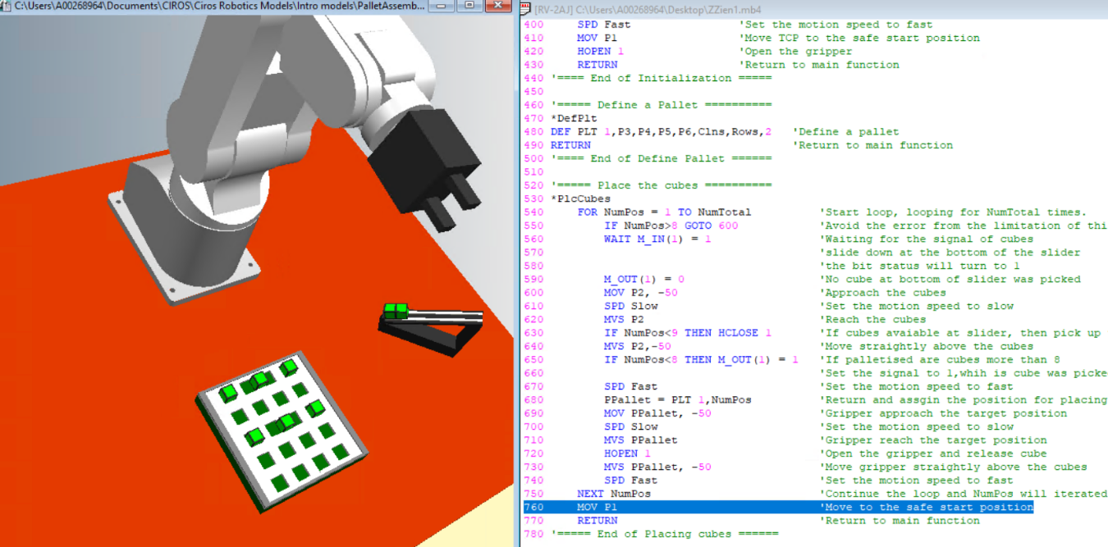

Figure 9: 2X3 test result

Meanwhile, the interaction with slider via IO control will be involved as shown in comment:

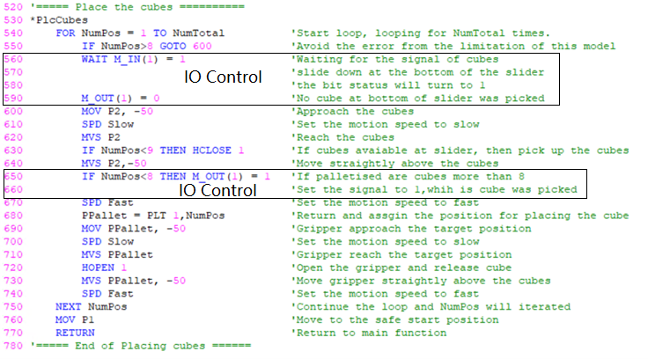

Figure 10: Part A(3)

Position:

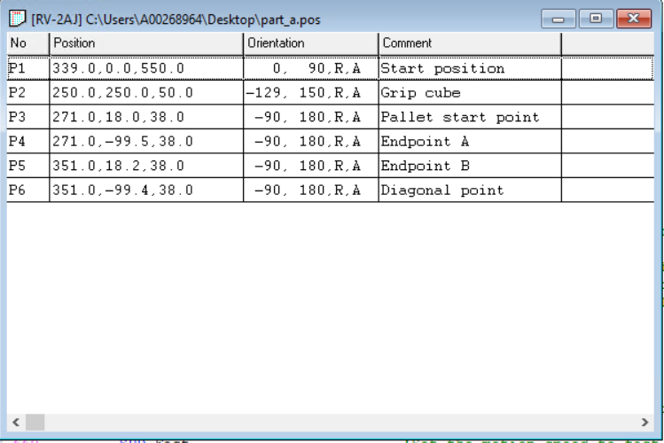

Figure 5: Part A

Part b:

7 functions in main loop.

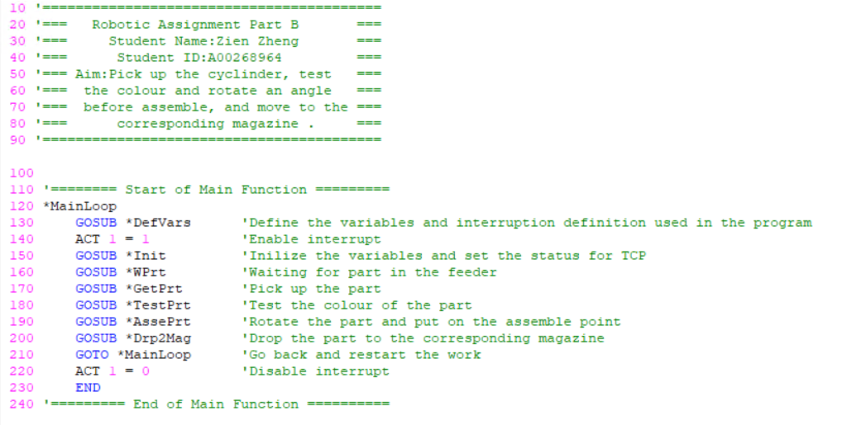

Figure 11: Part B(1)

*DefVars: Definition of variables and interruption function.

*Init: Assign the values for variables and initialize the speed, start position, and open the gripper.

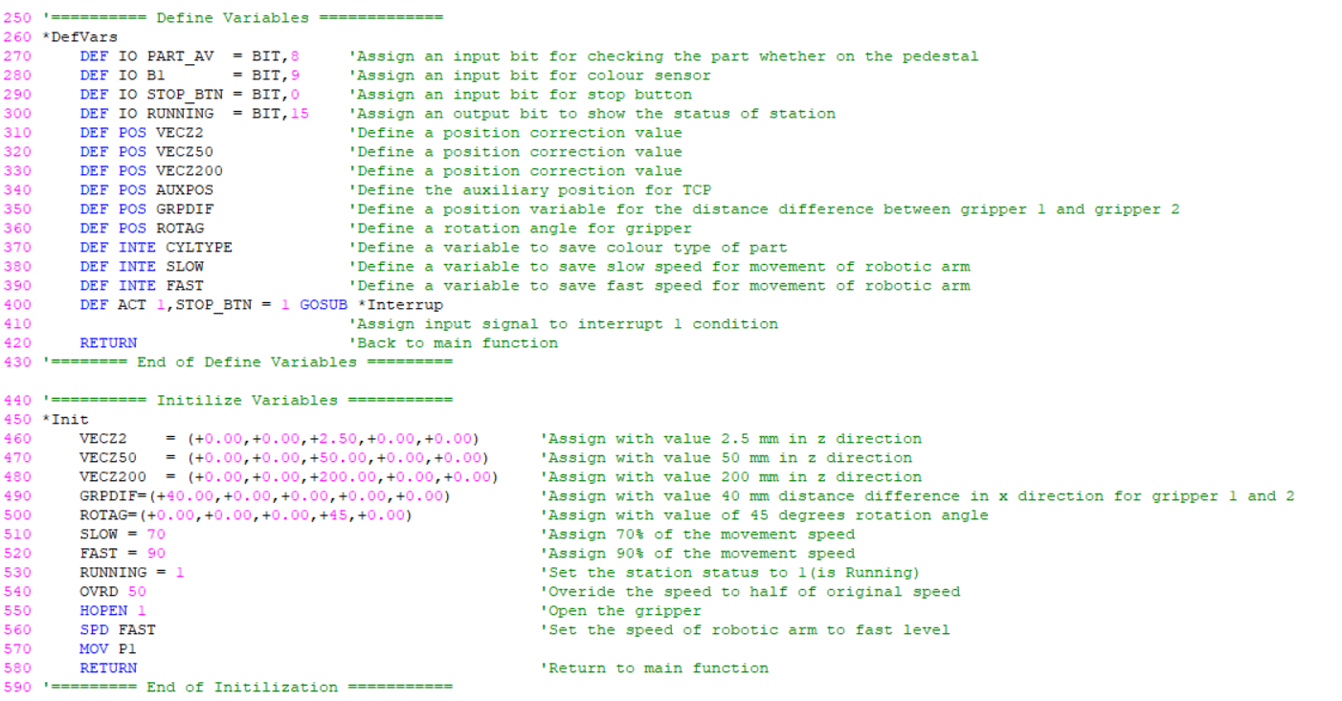

Figure 12: Part B(2)

*WPrt: Check PART_AV to determine whether the part is available on the feeder.

*GetPrt: Pick up the part with gripper 1.

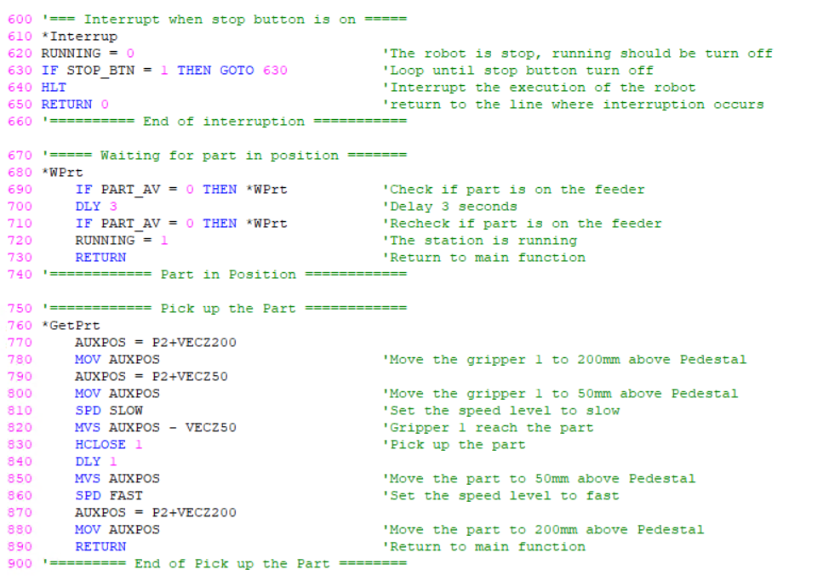

Figure 13: Part B(3)

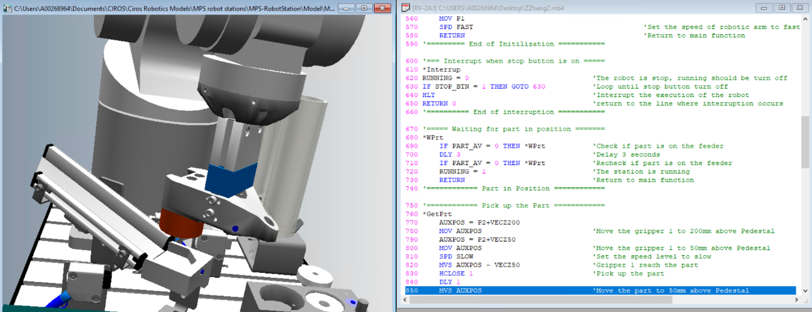

Figure 14: Part picked

*TestPrt: Move part to the test point and activate the sensor to get the colour type.

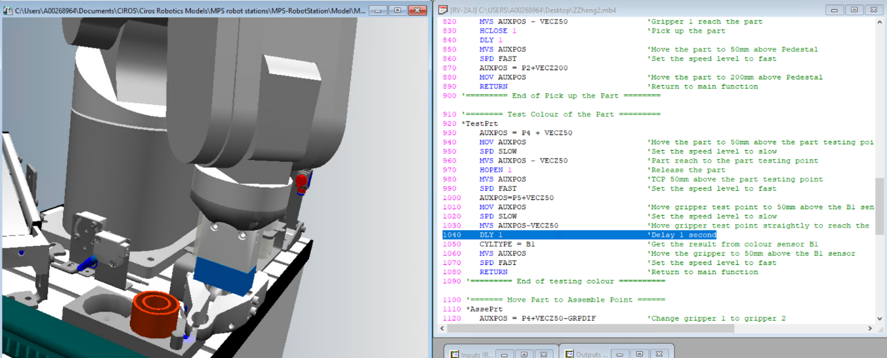

Figure 15: Activation

*AssePrt: An x-direction correction value is used for changing gripper1 to gripper2 to pick the part, and rotation auxiliary angle ROTAG is being used before moving to the assembly point.

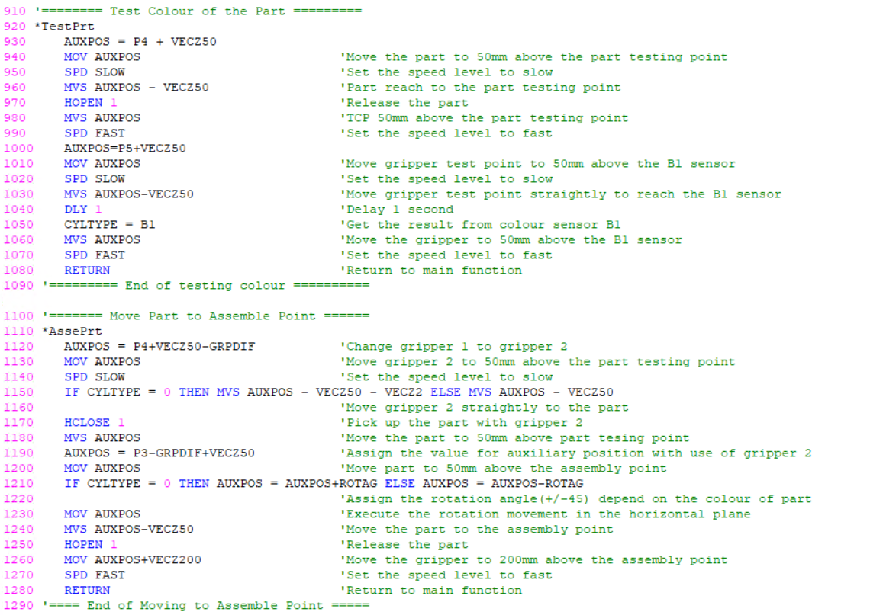

Figure 16: Part B(4)

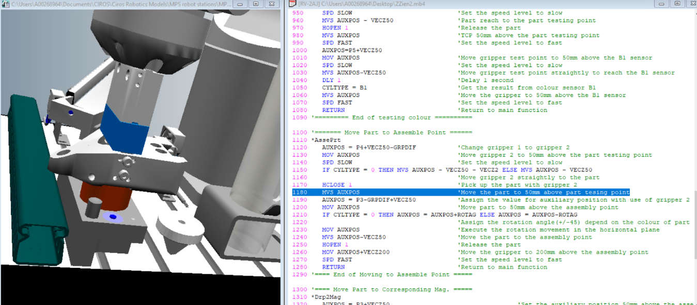

Figure 17: Use gripper2

*Drp2Mag: Pick the part and use CYLTYPE to move to the corresponding magazine and use MVC to draw a circle.

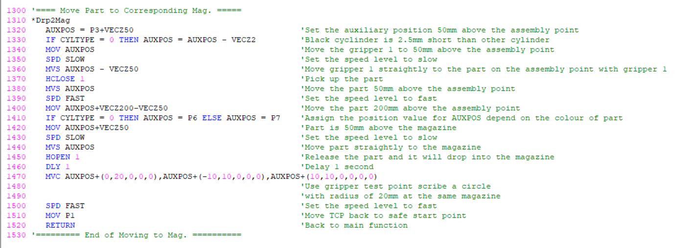

Figure 18: Part B(5)

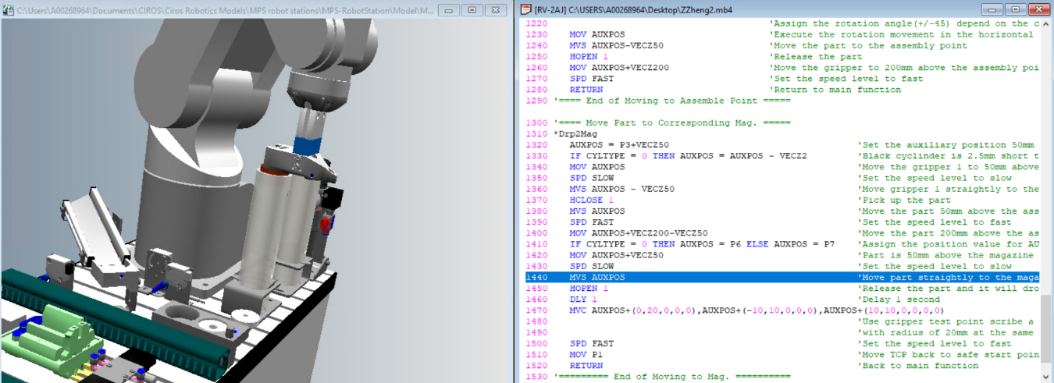

Figure 19: Store

Position:

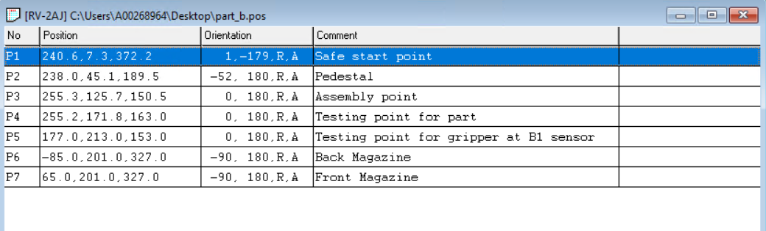

Figure 20: Part B

Discussion (Part a[200 words], Part b[597 words])

Part a:

* Application

The robot can be used to palletise the parts in industrial manufacturing, based on the definition of PLT function, the range for first parameter is from 1 to 8, this means the robot can palletise the part for 8 pallets maximum, which can highly increase the efficiency.

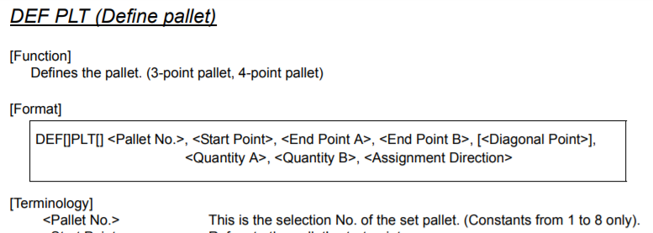

Figure 21: PLT definition

* Problems

The range for rows and columns is between 1-4, which are 16 cubes maximum but only 8 cubes available in this model. The solution is shown:

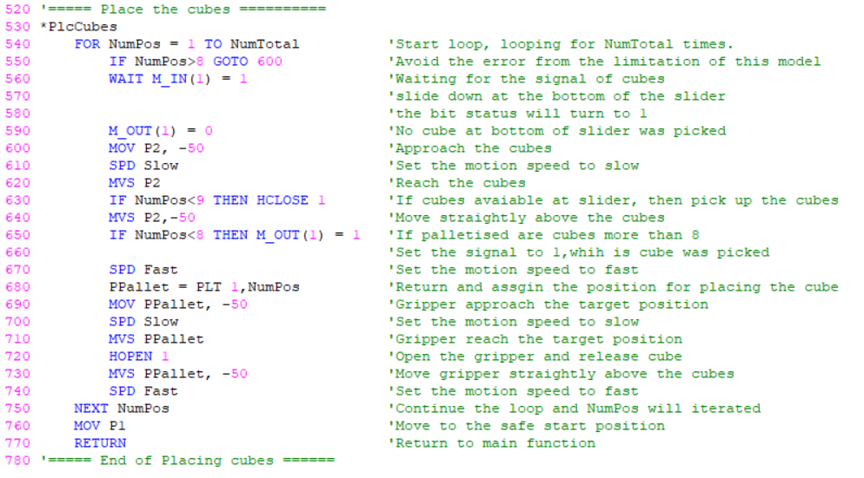

Figure 22: Solution

At line 550, IF-THEN was used to judge palletised cubes numbers, if is greater than 8, the program will skip setting IO status for slider, and at line 630 it will keep the gripper open so the palletise can continue or the program will run as normal.

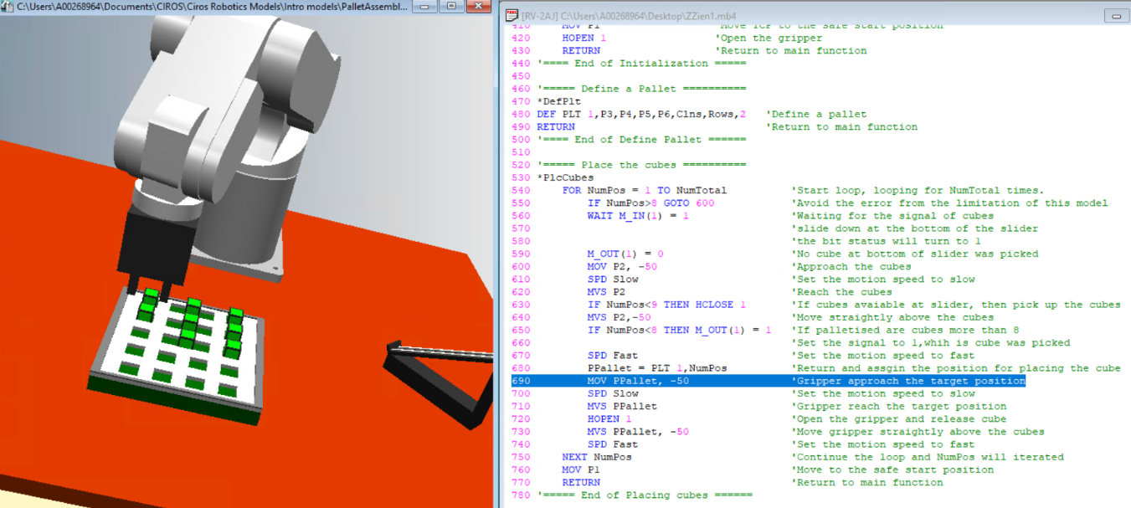

Figure 23: 3X3 Test

* Improvement

In real manufacturing, the part with glitches like weight is not enough, and this part will be tested. If use 2 pallets storing good and bad part, respectively, and a weight sensor to judge the weight of part, then, the robot can palletise good parts and bad parts on different pallets, thus, the quality control can be done automatically by robot.

Part b:

* Problems & Solutions

1. Speed

2 levels of speed are defined:

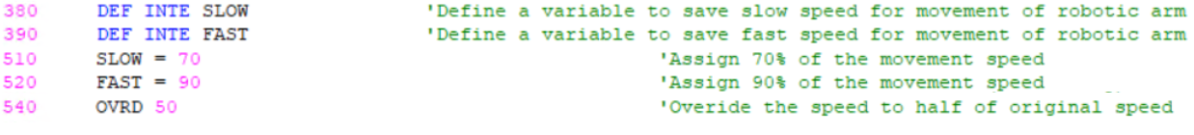

Figure 24:Speed control

Use OVRD 50, the actual speed for the robot is $\frac{50×(SLOW or FAST)}{100×100}$ of the original speed.

Fast level is used for transferring or approaching part, and slow level is used to pick up or put down part. The following graph shows the logic of speed control in this program.

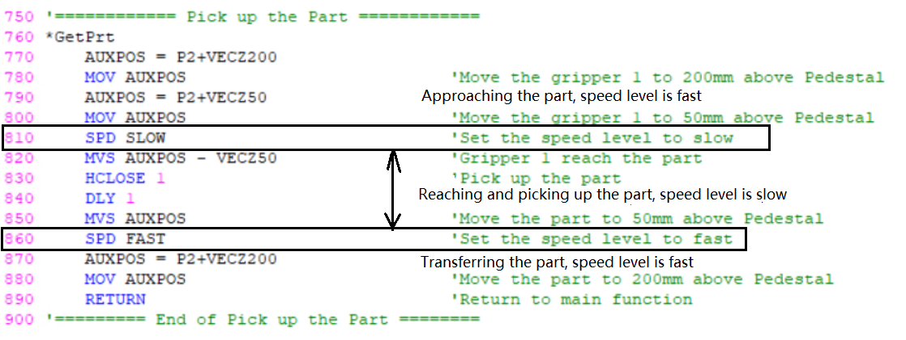

Figure 25: Speed setting

1. Gripper

Dimension of the gripper is shown:

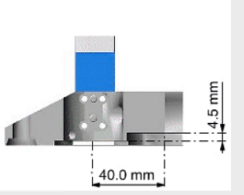

Figure 26: Dimension

In x-direction, centre to centre distance between gripper 1 and 2 is 40mm, based on this, a correction position variable can be defined for changing the gripper.

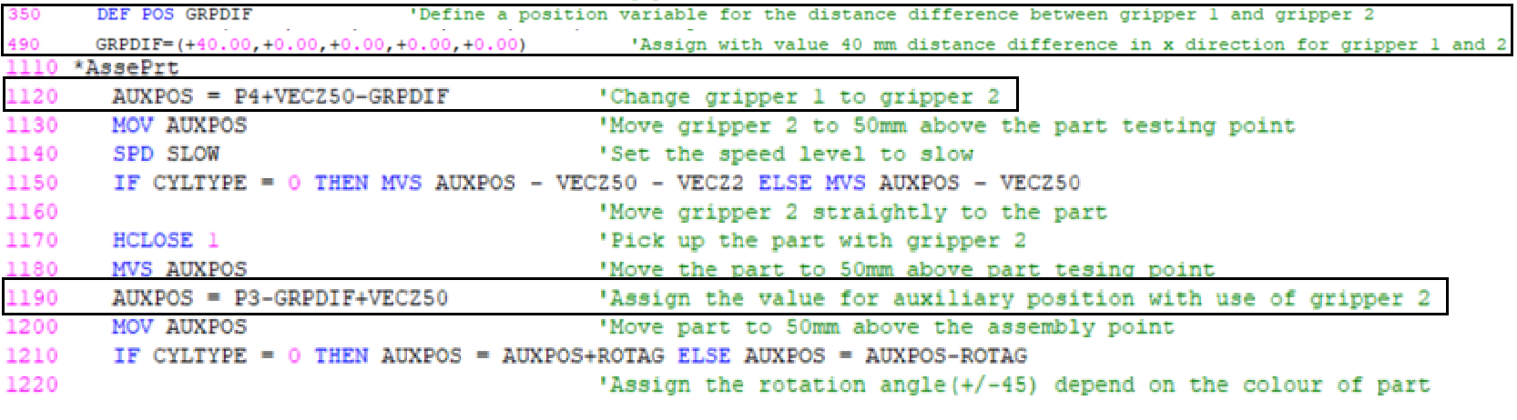

Figure 27: Change gripper

P3 and P4 are taught position, use these positions to subtract distance difference (GRPDIF), and assign value to auxiliary position (AUXPOS) the gripper can be switched to gripper 2.

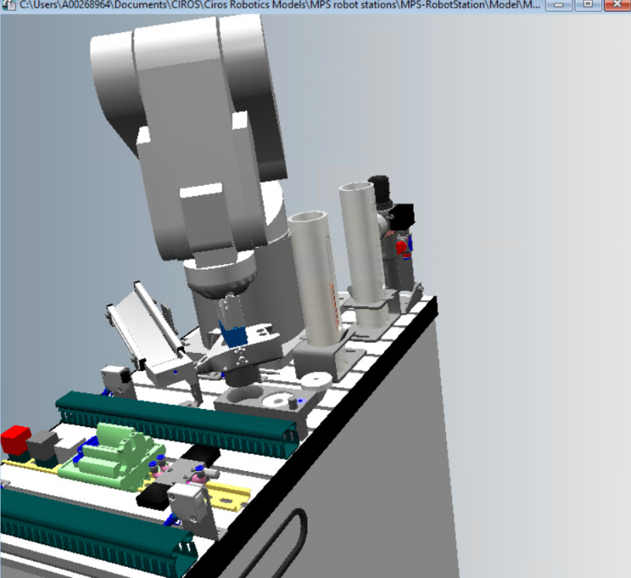

Figure 28: Use gripper2

1. Interruption

The definition of the stop button, ACT:

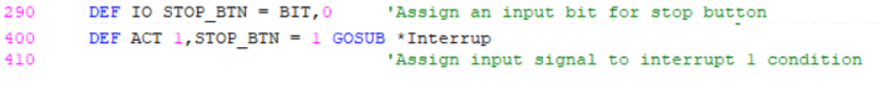

Figure 29: Definition

A bit is assigned for stop button. When defining ACT, the priority is set 1, and condition for triggering the interruption function is when the stop button is turned on (to 1).

Interruption solving is shown:

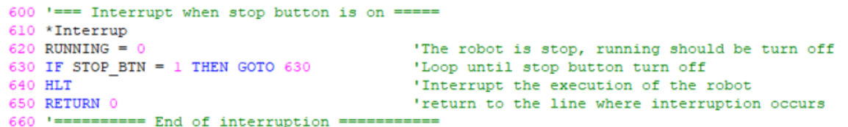

Figure 30: Interruption

Once interruption is called, the robot will stop and looping, meanwhile, running status will be turned off, loop will constantly checking if the stop button is turned off, if it is off, with HLT function, the program will stop without condition and restart.

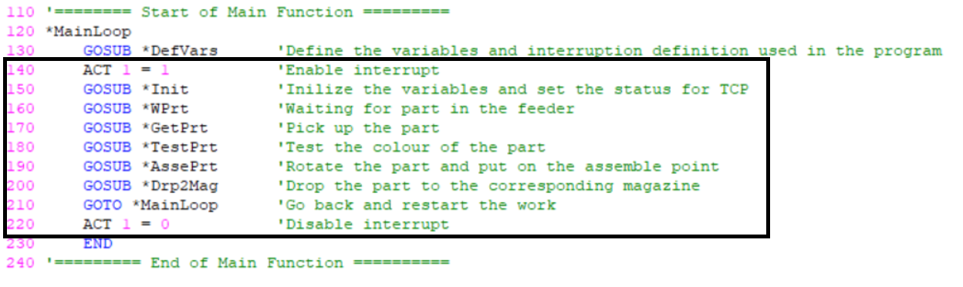

Figure 31: Interruption monitoring period

The interruption monitoring period contains the whole process when the robot is in operation as shown above.

1. Colour

When part put on the test point, B1 is a colour sensor, it will be activated when gripper test point reach to it as shown:



Figure 32:Sensor

Then, the B1 will return the testing result to the variable CYLTYPE. (0 is black, 1 is not black)

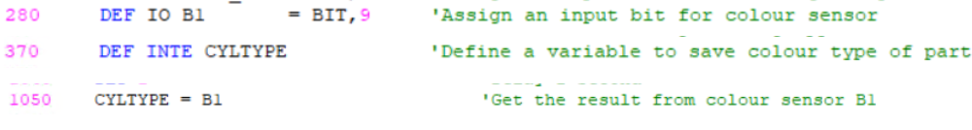

Figure 33: Definition of B1, CYLTYPE and store result

1. Rotation

Rotation will depend on the colour of the part, and colour type is stored in CYLTYPE variable after test, then, IF-ELSE command is used to determine the rotation direction as shown:

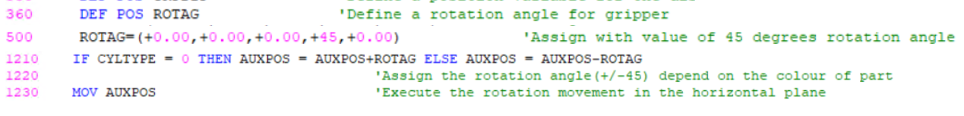

Figure 34:Rotation

A position variable ROTAG has stored +45 degrees of the rotation angle, in line 1210, AUXPOS is the current position of the gripper, CYLTYPE is 0 if is black, the rotation angle ROTAG will be added to the current position or is not black part, the current position will subtract the ROTAG and will move -45 degrees.

1. Scribe circle

When drawing the circle, MVC command is used, the 3 required parameters are shown as follow:

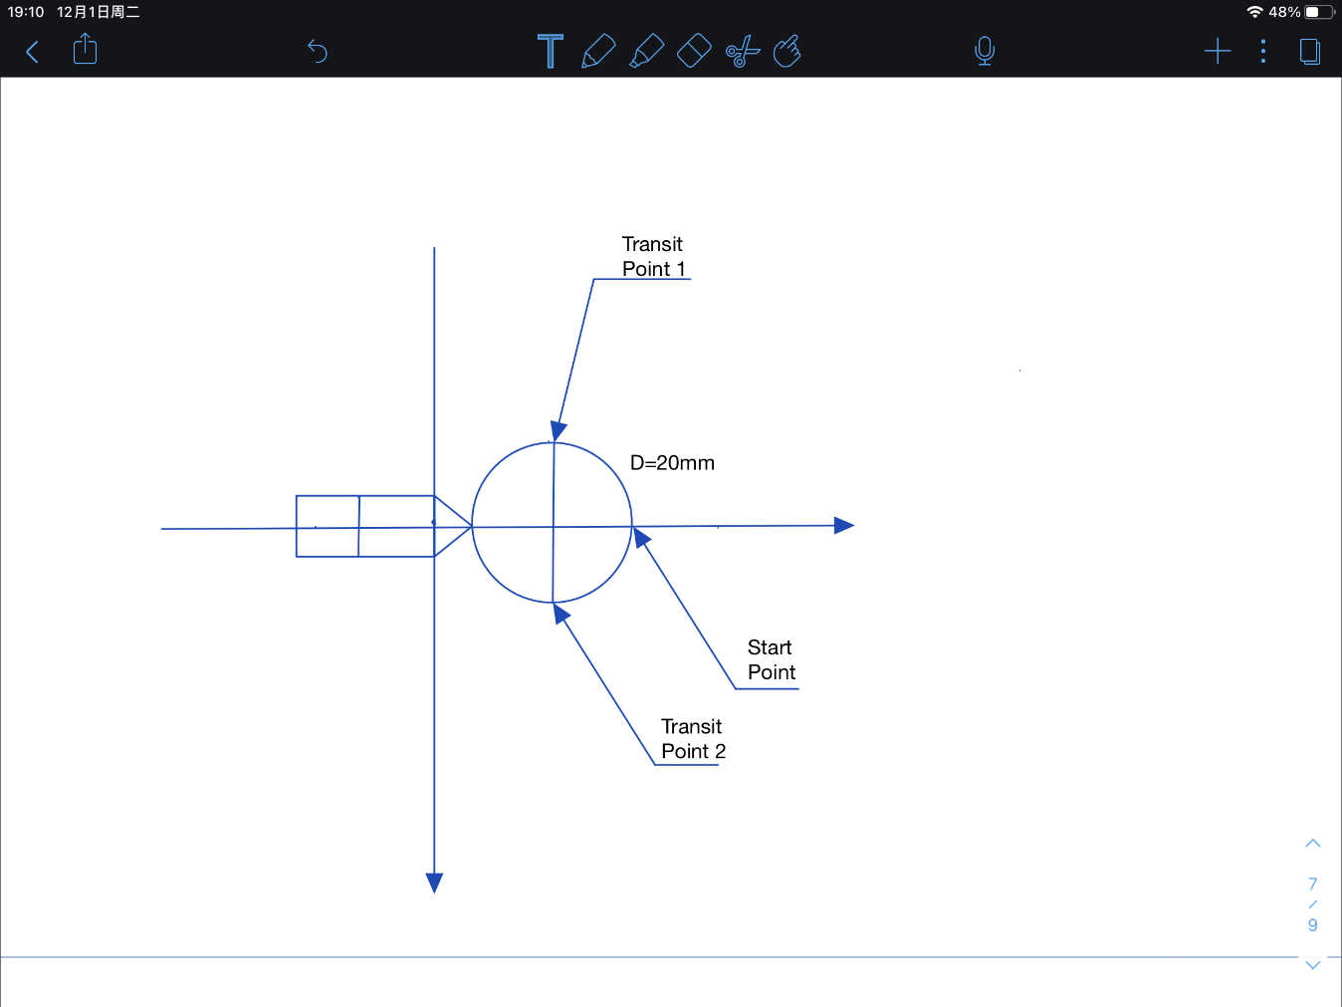

Figure 35: Circle

The diameter of this circle is 20mm, based on the graph, the movement can be achieved in the code as shown:



Figure 36: Code for scribe circle

1. The black cylinder is shorter 2.5mm than the other cylinders.



Figure 37: Z-correction variable

The solution is using a correction position in z-direction VECZ2 to ensure the part is gripped properly.

* Application

The robot can be used in the manufacturing line for picking up the part and test its colour, assemble it and store it.

* Limitation

The gripper has a fixed size, so the part is also required in this size, this will limit the functionality of this robot, for example, it cannot pick up the part of cube.

* Improvement

1.Use sensor 2 so that can make an angle test for part.

2.Change of sensors or gripper will extend its functionality.

* Personal Learning

The usage of CIROS Robotics was learned, the programming language MelfaBasicIV also being understood and applied in this assignment.

Conclusion (49 words)

The testing result shown in the video has demonstrated the feasibility of codes that has achieved the goal for both parts, which are palletising the cubes of interacting with the slider in part a, and test, assembly, classification of parts to move to the corresponding magazine in part b.